**Obj-Methods: Used to perform actions on Internal Data base:**

**Obj-Browse: Fetch Multiple Records for list of Properties**

**Obj-Open : Fetch single record based on Class key**

**Obj-Open by Handle: fetch single record based on Primary Key/pzInsKey**

**Obj -Save: Insert / Update Records**

**Obj-Delete: to Delete records**

**===**

**Diff b/w Pc, PR, PR4 Tables:**

**pc tables: Work Object Related data/ Transaction related data**

**pr4 tables: PEGA Rules are assigned to pr4 tables**

**pr tables: Data Tables ( Reference Tables & Business tables)**

**Reference Tables ( Master Tables): Data will be never Updated/Deleted**

**Ex: Account No, Name, PhoneNo, EmailID**

**Business Tables: are the transaction tables, here data can be updated, saved & Deleted**

**Ex: Account Balance**

**Working with Obj-Browse: (Dynamic Fetch)**

**Req: Create an Activity to fetch all State Codes & State Names from States Table**

**Create activity:**

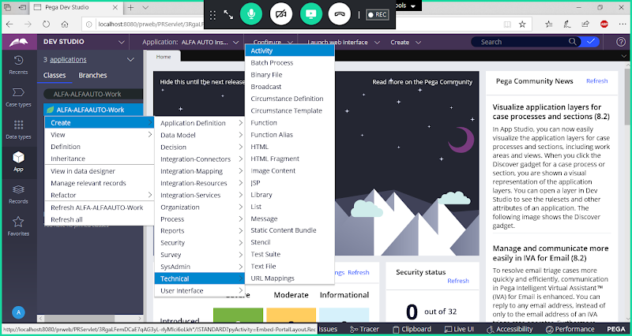

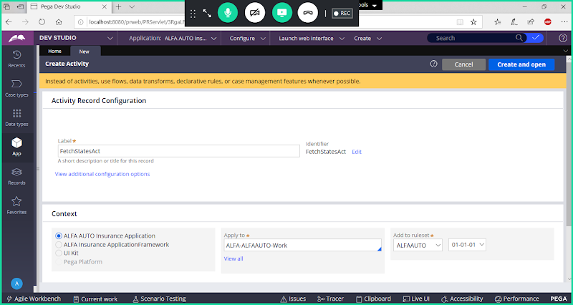

**Open**

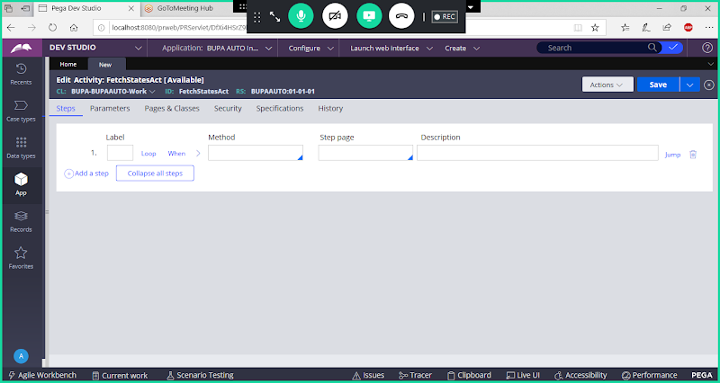

**When Using Only Obj-Browse method we will not use Page -New & Page -Remove Also No Need to Define Pages & Classes. In Obj-Browse Parameters you will have option to define Page Name & Class Name.**

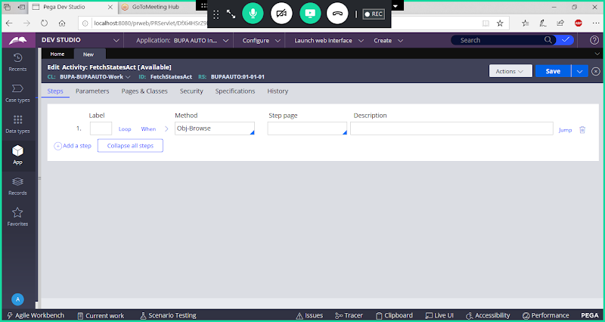

**Expand Obj-Browse & Fill Method Parameters:**

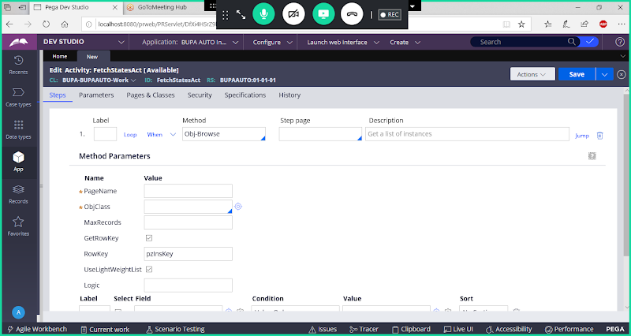

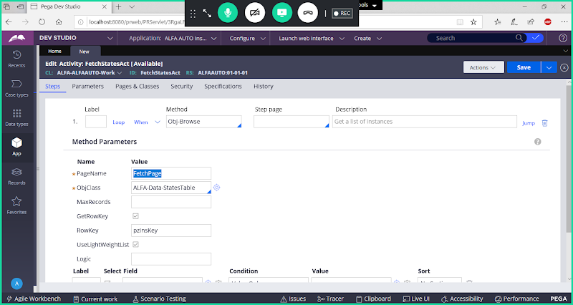

**Disable Get Row Key Option**

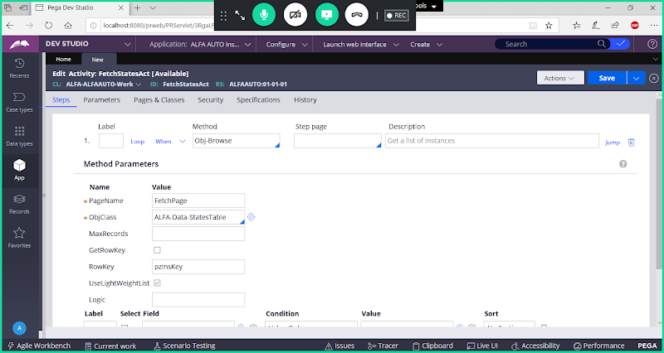

**Add Fields**

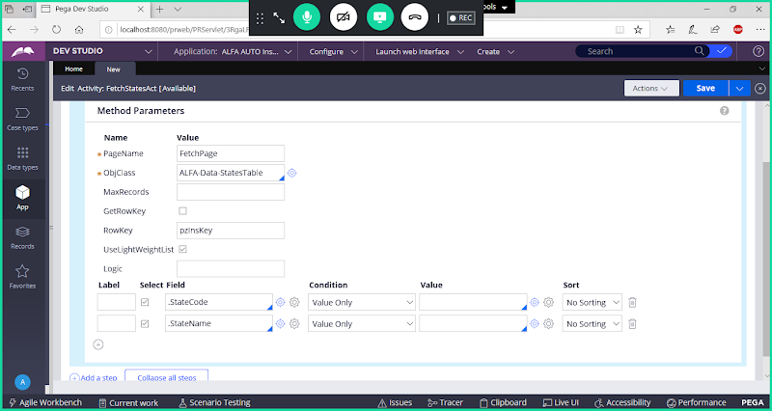

**Save Activity**

**Run Activity & Debug using Clipboard to check whether results are loaded to clipboard page or not.**

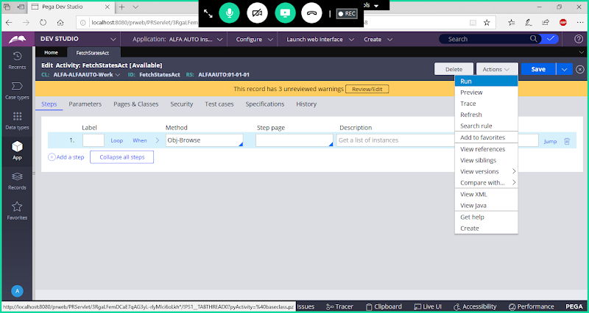

**After Run-> Open Clipboard,   Scroll Down & Search for FetchPage under User Pages in Clipboard:**

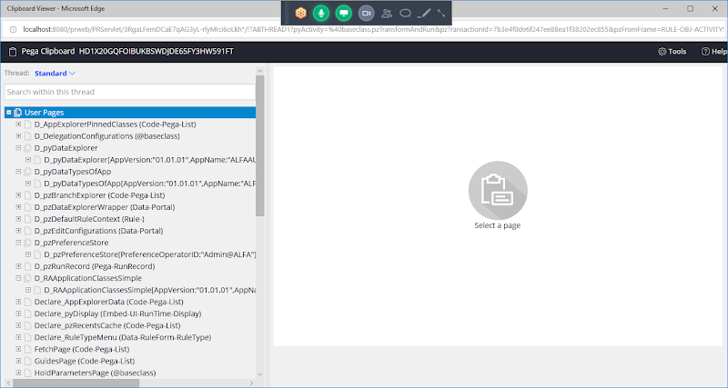

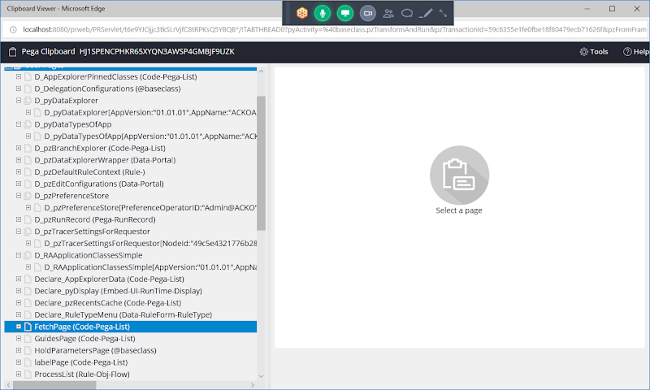

**Expand FetchPage:**

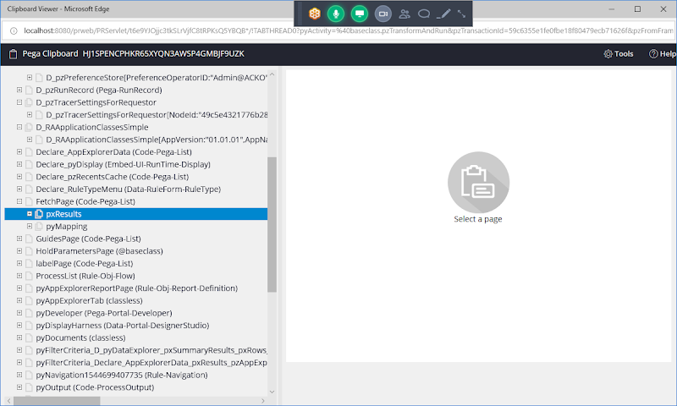

**Expand pxResults:**

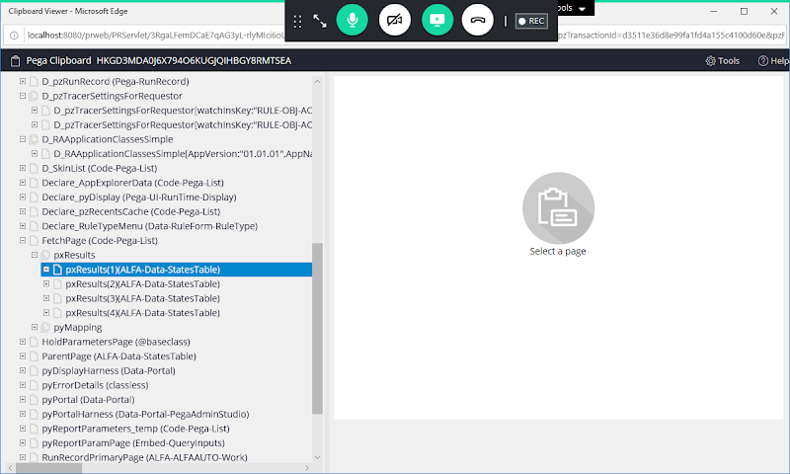

**Click on pxResults(1)**

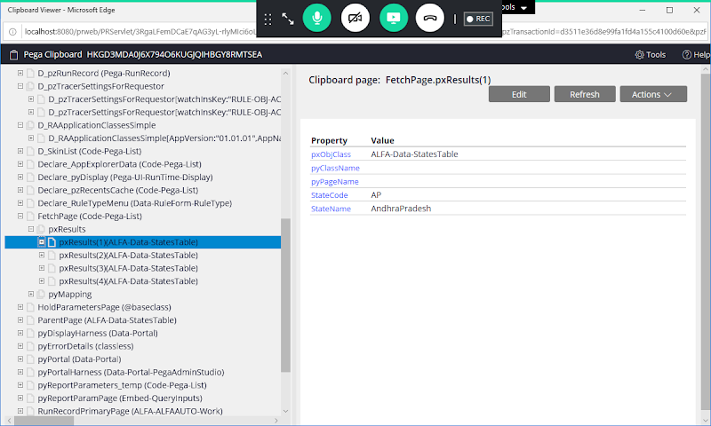

**FetchPage(Code-Pega-List)**

**Code-Pega-List:**

**When Using Obj-Browse/RDB-List all the results in Clipboard will be assigned to a Predefined List Class: Code-Pega-List**

**Expand FetchPage(Code-Pega-List):**

**pxResults:**

**pxResults is a predefined Page List Property, Which holds Multiple Properties & its Results under code-pega-list class.**

**After Obj-Browse/RDB List is Executed, results on Clipboard is available under below structure:**

**FetchPage( Code-Pega-List)**

**pxResults**

**pxResults(1)( ALFA-Data-Statestable)**

**StateCode: AP**

**StateName: Andhra Pradesh**

**pxResults(2)( ALFA-Data-StatesTable)**

**StateCode: KA**

**StateName: Karnataka**

**pxResults(3)( ALFA-Data-StatesTable)**

**StateCode: TN**

**StateName: TamilNadu**

**In above structure pxResults is an OOTB PageList Property available under OOTB Class Code-Pega-List.**

**All the Results are now available in the Clipboard under the Page : FetchPage.pxResults( Data Class)**

**Req: Customize Customer Details form with State (Dropdown/Auto Complete) & Map Activity for State Property using Clipboard Pages:**

**How to Remove Static Records:**

**Open State Property**

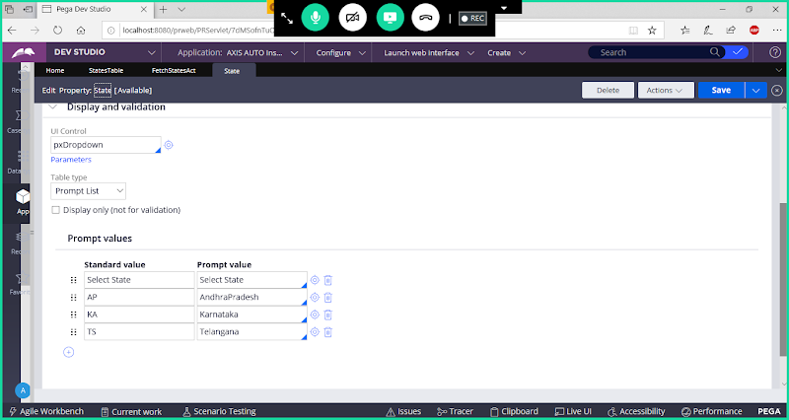

**If  Table Type contains any LocalList/Prompt List Values then Select Table Type as None.**

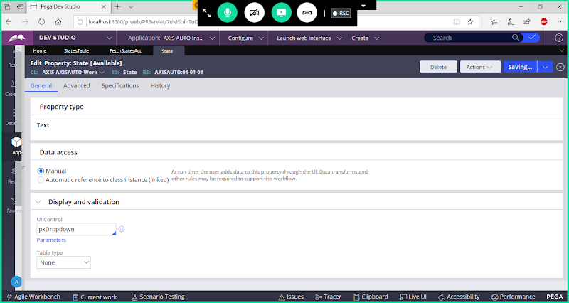

**Save Property**

**Open Customer Form & Change State Property Control to DropDown:**

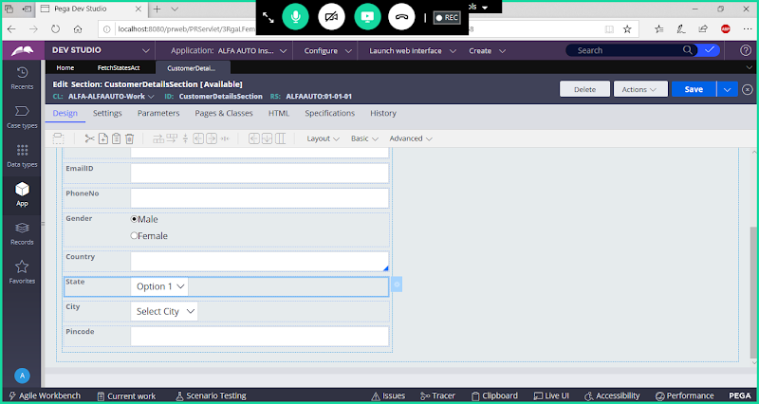

**Change State Property Control to DropDown:**

**If State Property Contains any Static Records, then Remove Them:**

**===========**

**In Customer Details Section go to Pages & Classes**

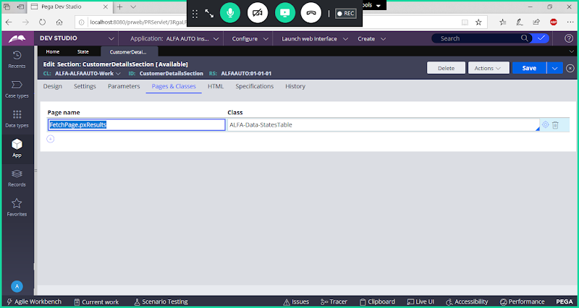

**Save Section & go to Design tab**

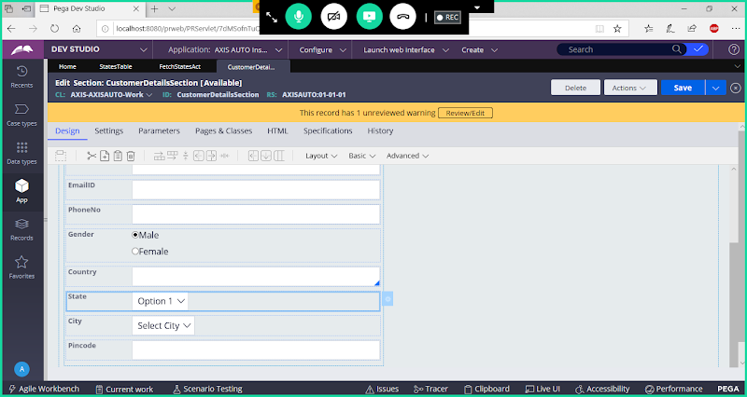

**Open State Property Settings**

**Add Caption for State Property:**

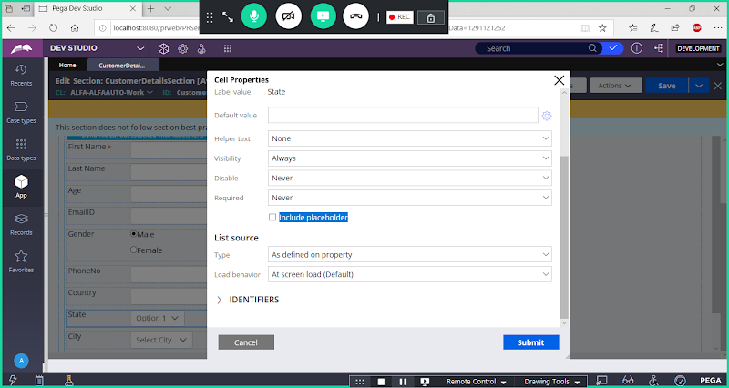

**Enable Include Placeholder Check Box & Add Caption:**

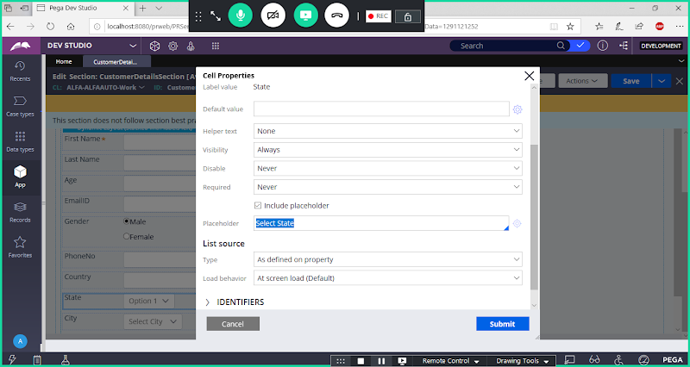

**Now Add List Source:**

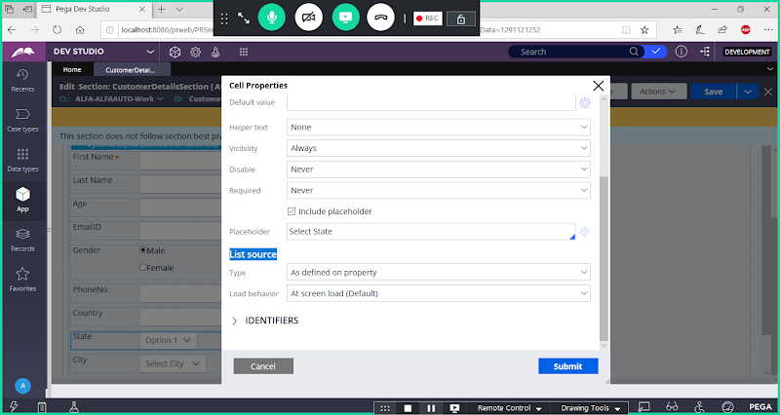

**Under Source Type Select: Clipboard Page**

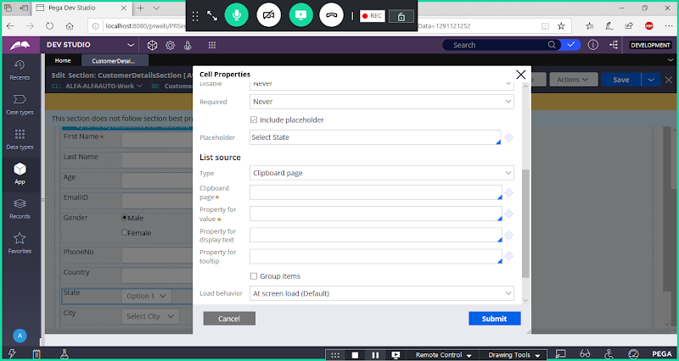

**Select Clipboard Page**

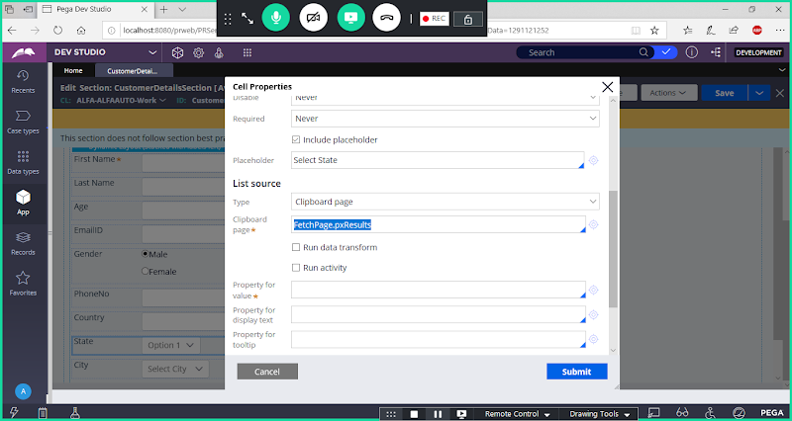

**Enable Run Activity**

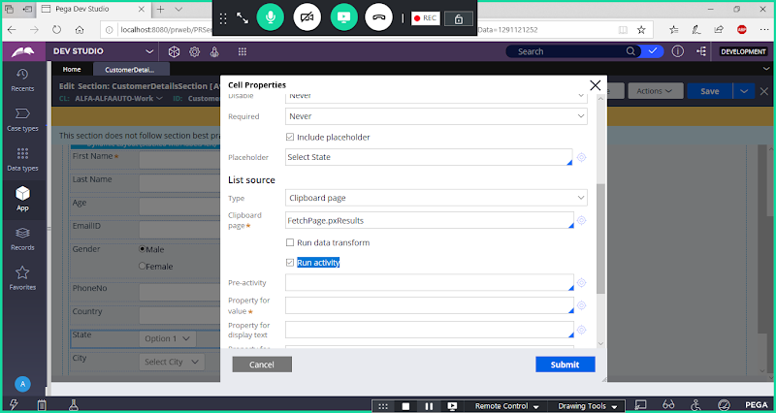

**Give Activity Name:**

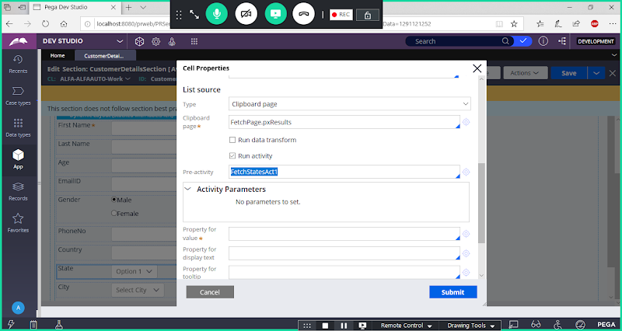

**Then Add Property For Value & Property for display text**

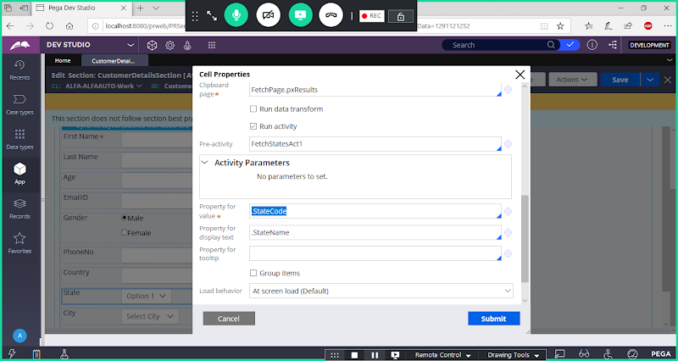

**Property for Value: State Code**

**Property for Display Text: State name**

**Submit**

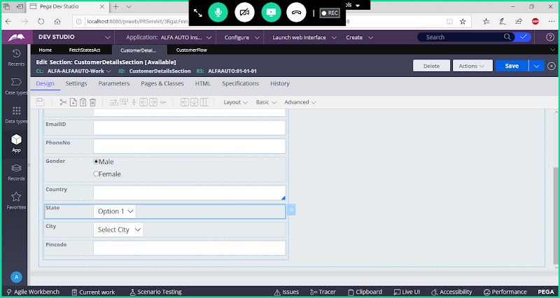

**Save section**

**Run Customer Flow / Insurance Flow & Verify**

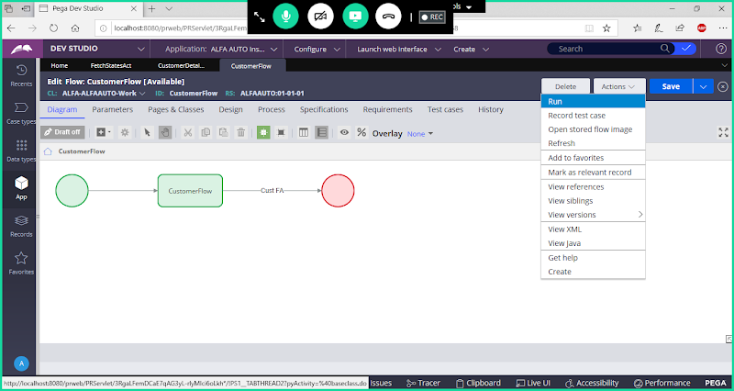

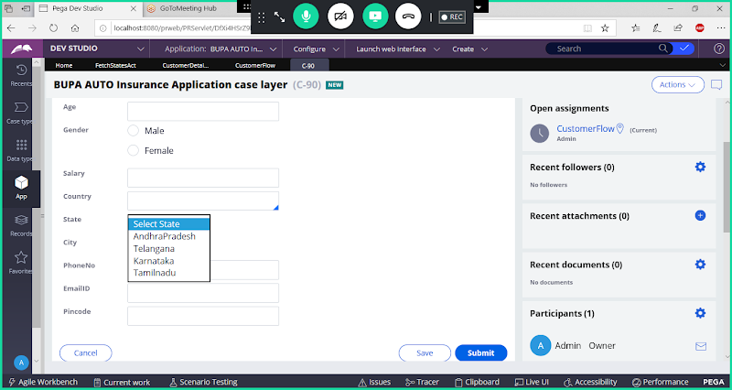

**Submit**

**Select Value : AndhraPradesh**

**Submit & Check Value in Clipboard**



